Performance Predictor Machine Learning Model

Here I have used multiple linear regression to create a model for predicting next season performance of some of the top forwards in the world right now. I have chosen Messi, Ronaldo, Neymar, Suarez, Aguerplewandowski,Mohammed Salah and Sadio mane for this study. This model analyzes the players’ performace for last 10 years and creates a model of their scoring pattern. And based on that predicts how many goals each of them are going to score in the upcoming season

Relevance of the model:

I divided the entire dataset into 80:20 ratio and allocated those data to training set and test set repectively. The model was created based on the training set data and I used the test set data as a performance analyzer. Here are the results:

|  |  |  |  |  |
| --- | --- | --- | --- | --- |
| Player name | Season | Predicted result (goals) | Actual result (goals) | Error percentage |
| Messi | 2013-14 | 45 | 45 | 0.92% |
| 2016-17 | 53 | 54 |
| Ronaldo | 2013-14 | 51 | 52 | 5.83% |
| 2016-17 | 45 | 41 |
| Neymar | 2013-14 | 27 | 18 | 39% |
| 2016-17 | 31 | 24 |
| Suarez | 2013-14 | 30 | 33 | 7.32% |
| 2016-17 | 34 | 36 |
| Salah | 2013-14 | 12 | 11 | 22.96% |
| 2016-17 | 26 | 19 |
| Mane | 2013-14 | 18 | 18 | 3.84% |
| 2016-17 | 14 | 13 |
| lewandowski | 2013-14 | 28 | 28 | 6.81% |
| 2016-17 | 38 | 44 |
| Aguero | 2013-14 | 27 | 28 | 3.21% |
| 2016-17 | 34 | 35 |

Next Season ( 2019-20) Prediction:

|  |  |
| --- | --- |
| **Player Name** | **Prediction (Goals)** |
| Messi | 54 |
| Ronaldo | 40 |
| Neymar | 36 |
| Suarez | 37 |
| Salah | 40 |
| Mane | 29 |
| Lewandowski | 48 |
| Aguero | 40 |

Detailed process:

Data collcetion and cleaning

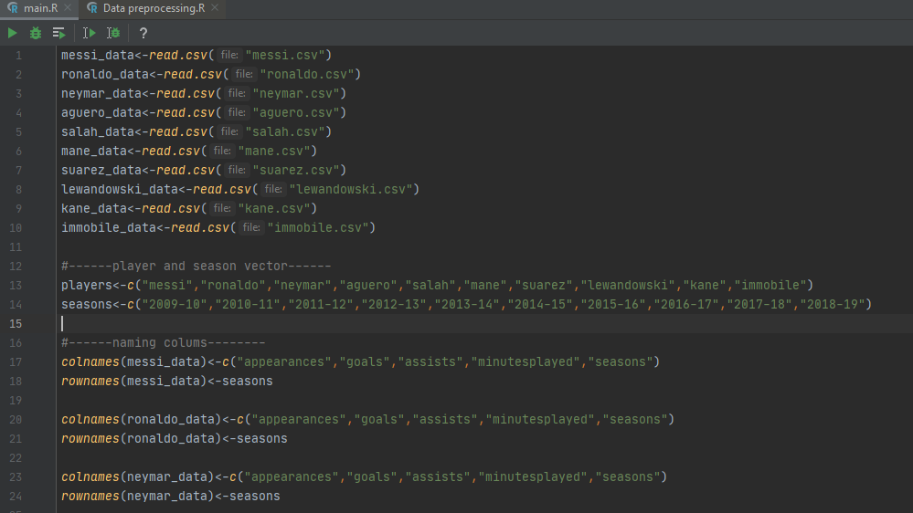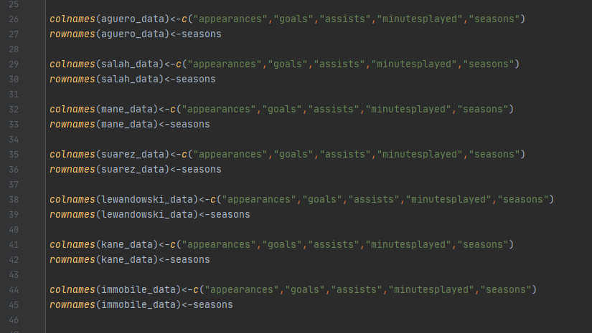

Creating regression model for Messi

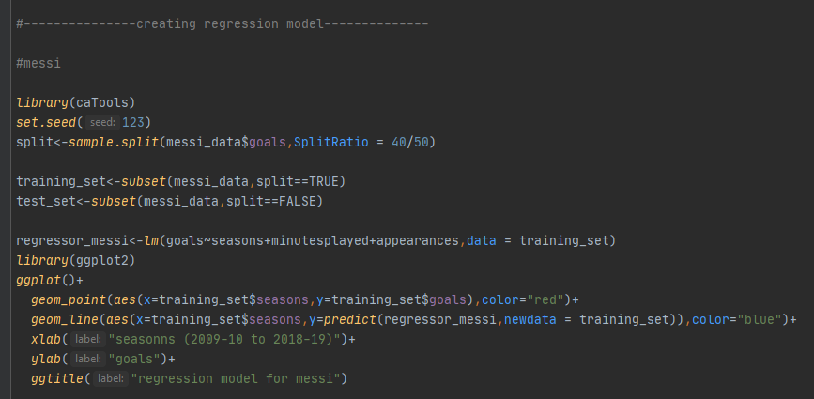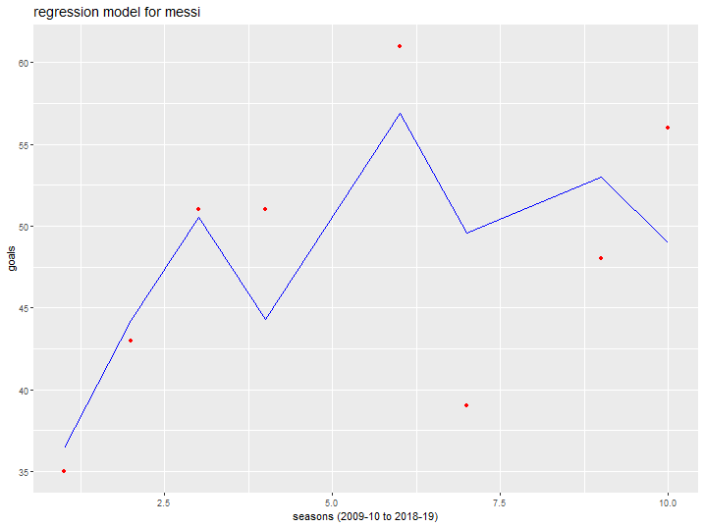

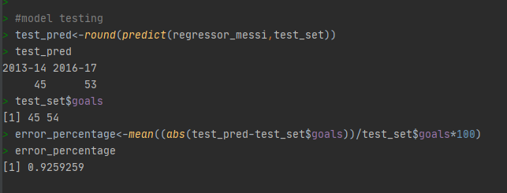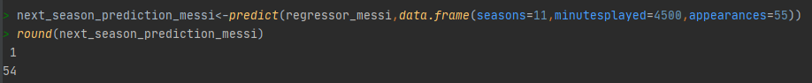

Creating regression model for Ronaldo

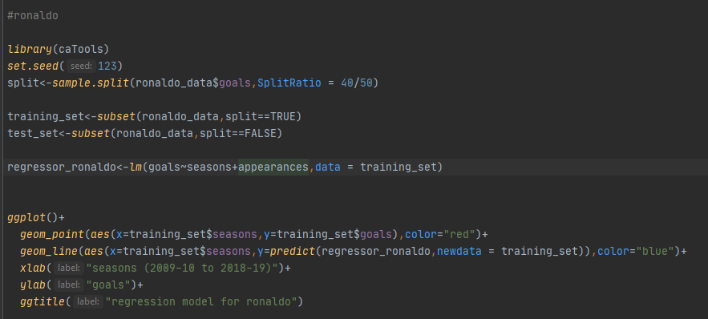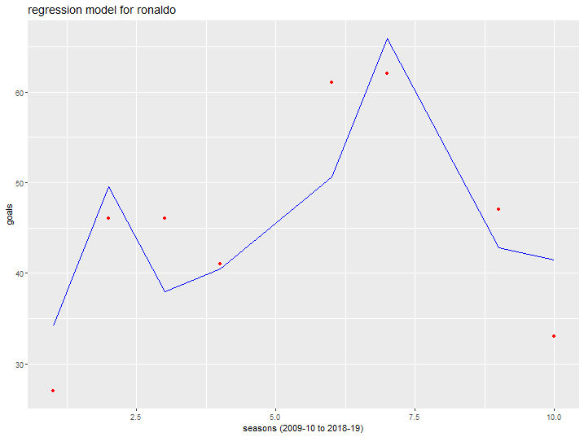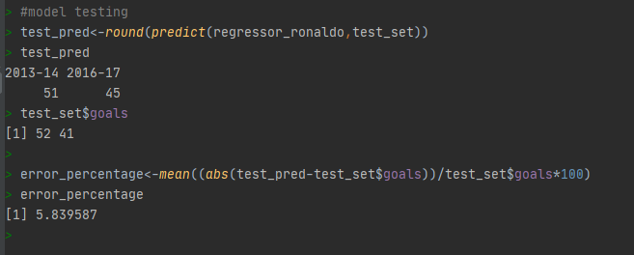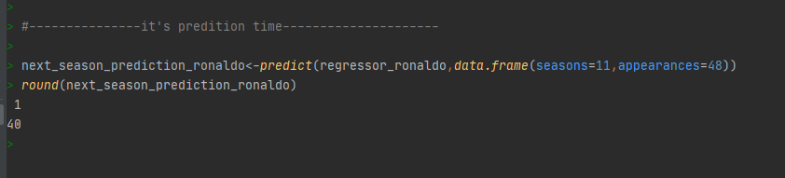

Creating regression model for Neymar

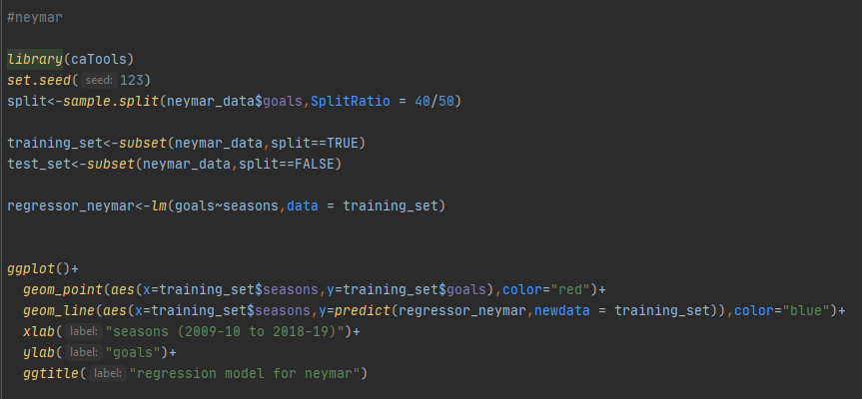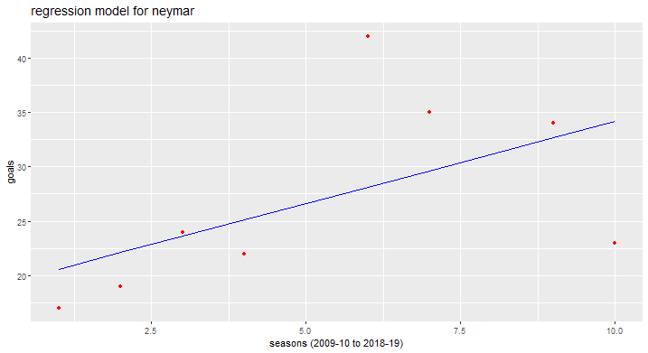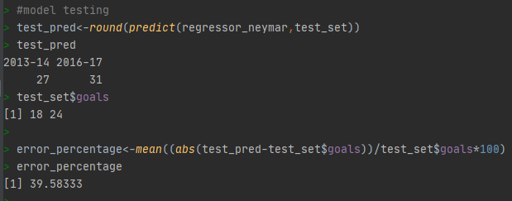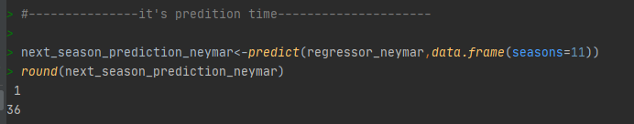

Creating regression model for Luis Suarez

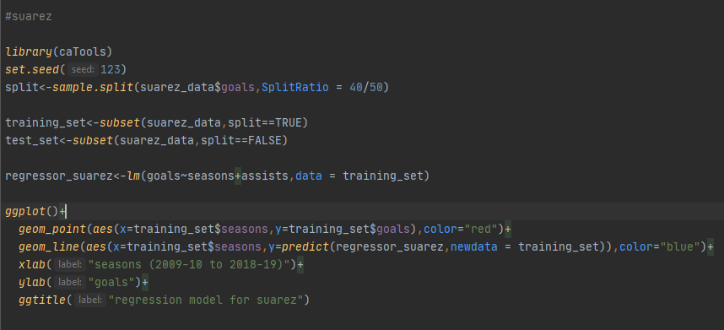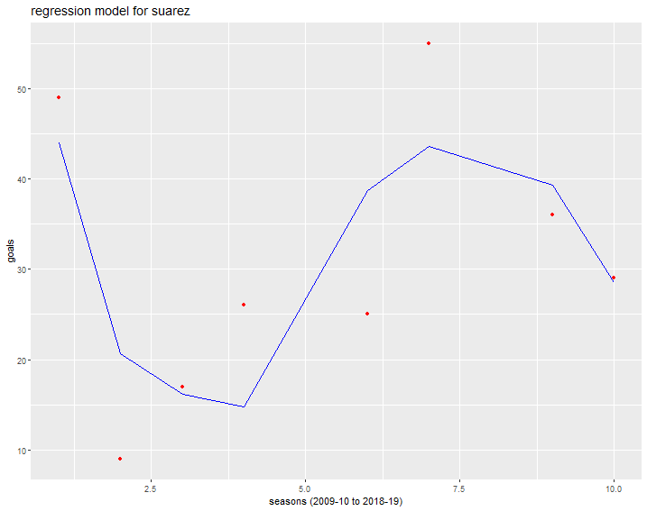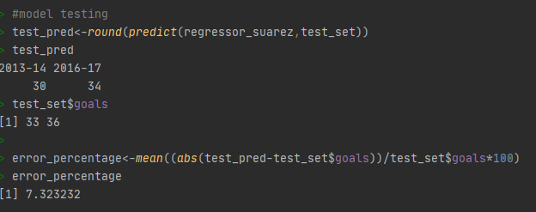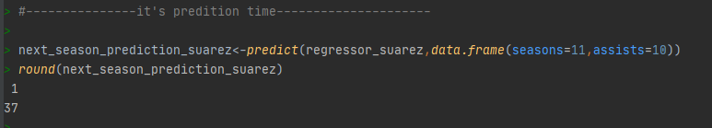

Creating regression model for Mohammed Salah

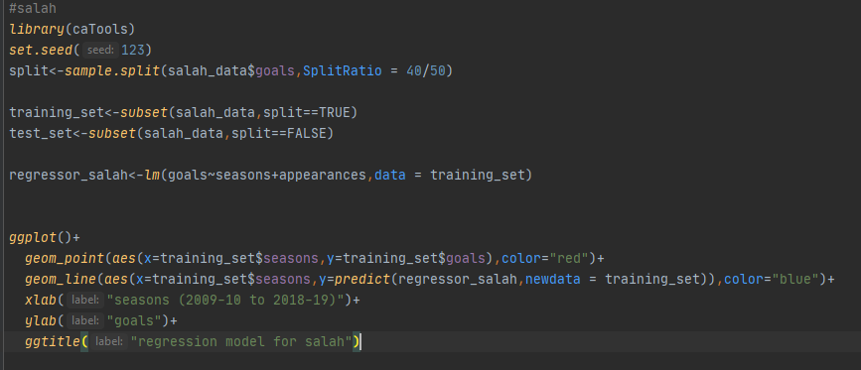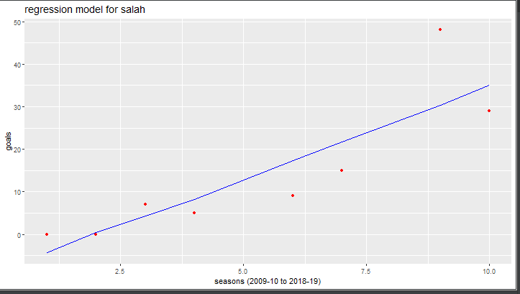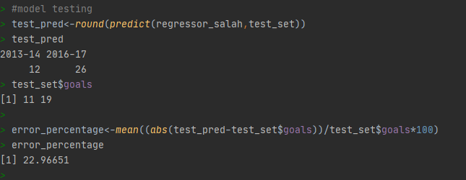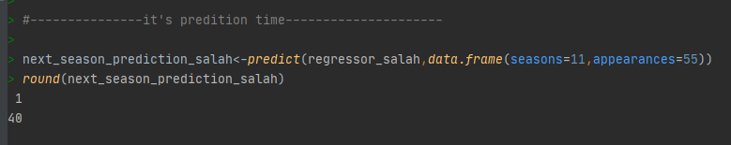

Creating regression model for Sadio Mane

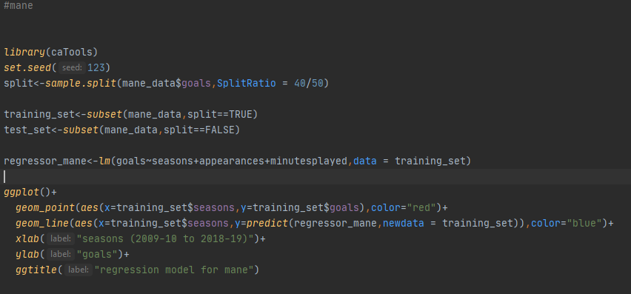

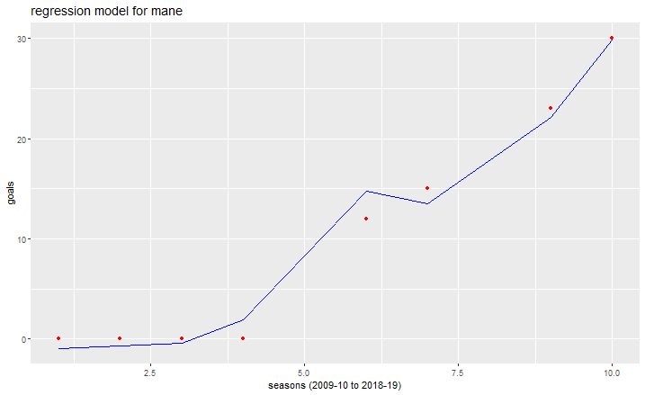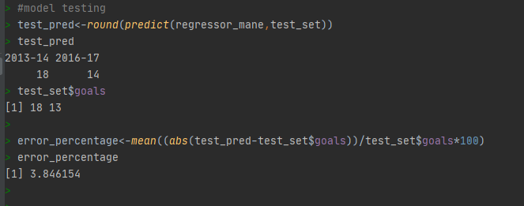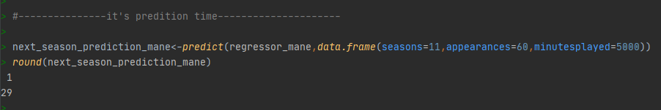

Creating regression model for Robert Lewandowski

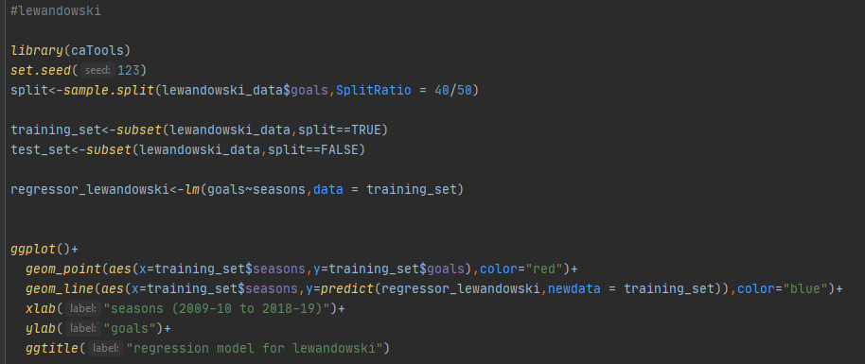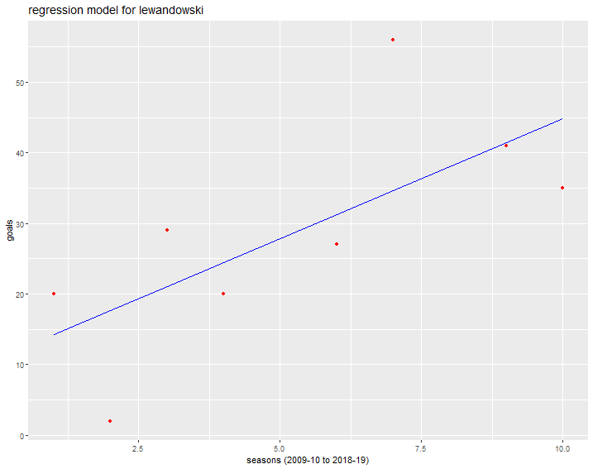

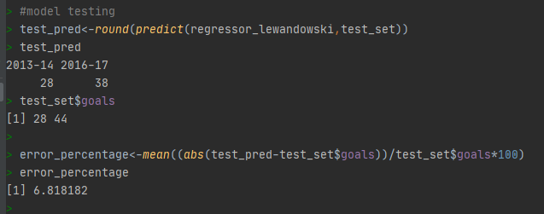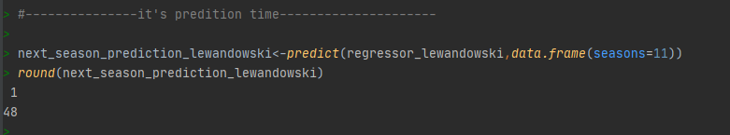

Creating regression model for Aguero

